Third order geometric nonlinearity analysis of a double-bar Biot truss

*(solved by four different numerical methods)*

Input data

Strut length -

Material - steel. Modulus of elasticity -

Cross section - circular with diameter . Area -

Axial stiffness -

Vertical force -

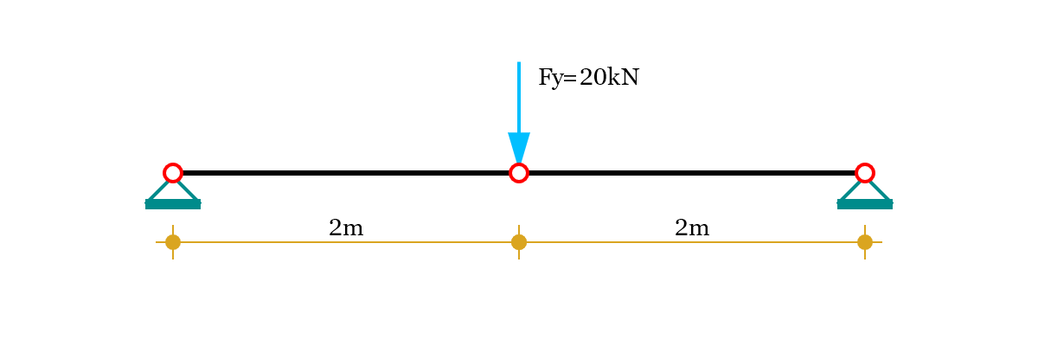

Solution

Because of the symmetry, the horizontal displacement in the middle is .

The vertical displacement is the only unknown - *v* = ? P

Since the system is linearly unstable, we use 3-rd order geometric nonlinearity theory for the solution. The equilibrium equations are then derived for the deformed state of the structure, as follows:

Length and elongation in deformed state

,

Horizontal reaction -

Vertical reaction -

Vertical reaction derivative -

1. Fixed point iteration method

Relative strain -

Relative precision -

Initial value -

We express the unknown vertical displacement at the middle joint as a function of the vertical force:

After calculating the above expression iteratively times, we get:

Relative error -

2. Newton-Raphson′s method

Initial value -

We repeatedly calculate the following expression:

After iterations we get:

Relative error -

3. Secant method

Slope reduction factor -

Initial value -

Force value -

We calculate the first approximation using Newton-Raphson′s method

Force value -

The next approximation is evaluated by the formula:

We continue the calculations iteratively until we reach convergence.

After iterations we get:

Relative error -

4. Solution with Calcpad (modified Anderson-Bjork′s method)

System behavior graph (force-displacement)

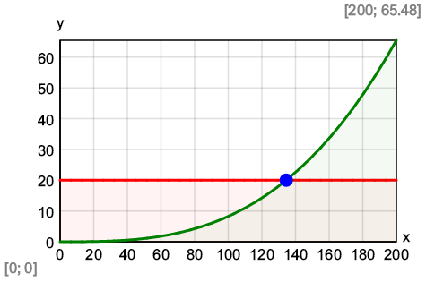

Results

Axial forces in bars -

Rotation angle - °

Reactions in supports

Horizontal - =

Vertical - =

